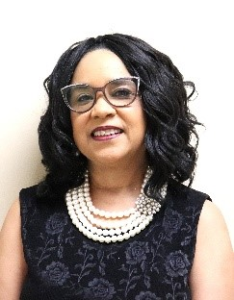

Marsha Roundtree
Church Administrative Assistant
Keeps complete records of the transactions of all business meetings; keep records of the church membership, record of baptism, list of deaths, suspended, prepare bulletins/programs and prepares all correspondence, sends out personal statements to members of their yearly gifts and serves as finance secretary in assisting the finance chairman.
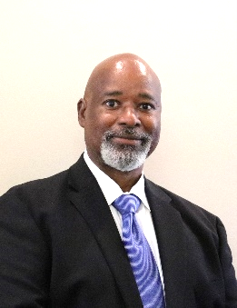

Weldon Stokes
Finance Chairman
The Finance Chairman is responsible for the financial records of the church.
Weldon Stokes – deacon for over 30 years, Finance Chief, member of the Usher Ministry, Culinary Ministry and Official Team.
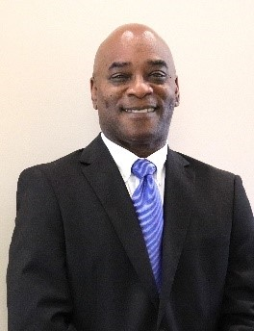

John Burnett
Finance Vice Chair
The Finance Vice Chairman is responsible for the financial records of the church when the chief is not available and to assist the finance chairman when needed.
John Burnett has been a deacon for over 20 years, serves as a member of the Ushers Ministry, Finance Vice-Chairman; and is a member of Culinary Ministry and a member of the Official Team

